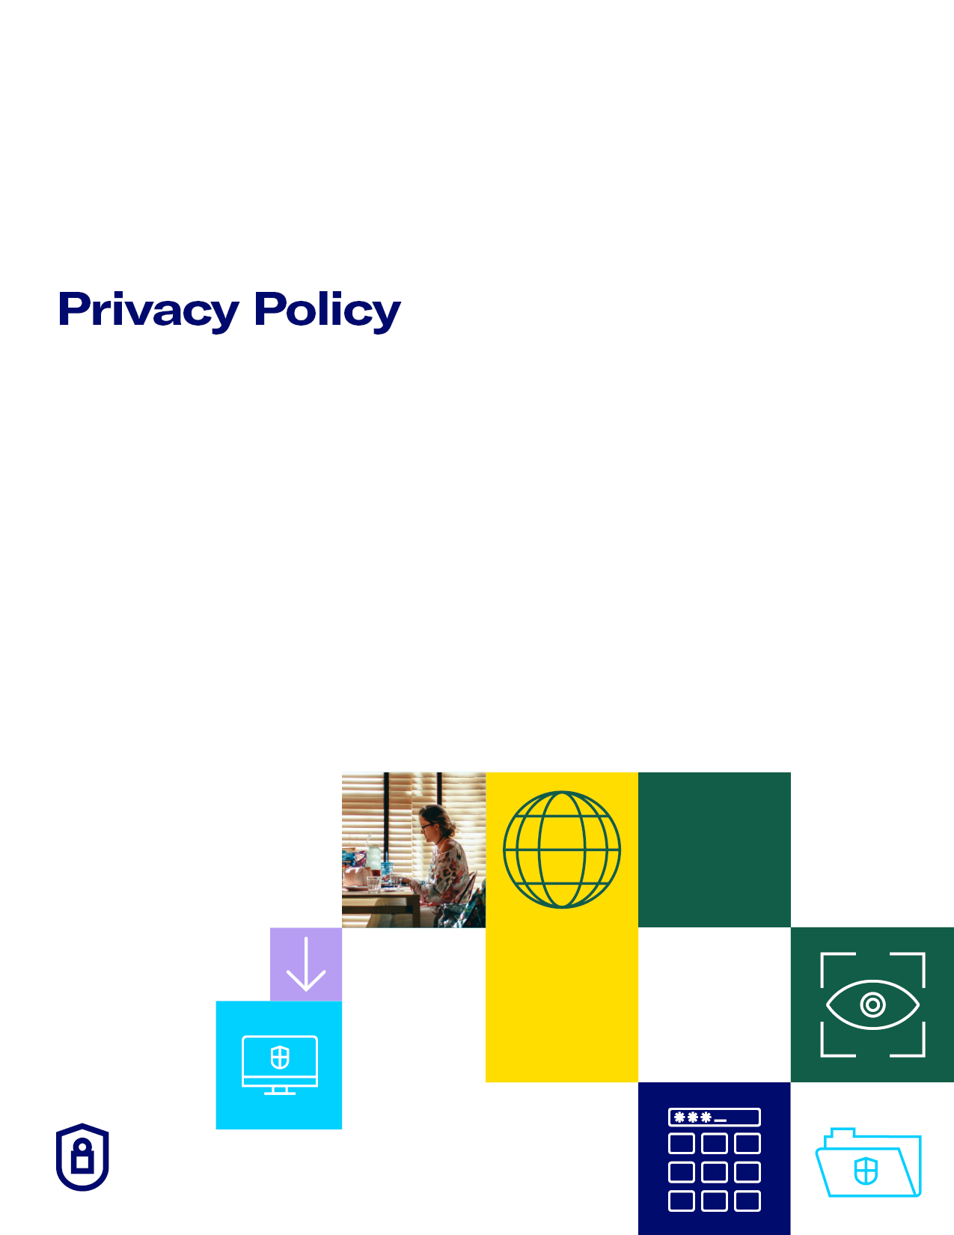

**PLATINUM CLOUD CONSULTING PTY LTD**

__________________________________________

**PRIVACY POLICY**

**__________________________________________**

Provided by:



Prepared by:



**DISCLAIMER**

*This Privacy Policy has been prepared and is provided as a template based on a typical accounting firm scenario. Please be aware that factors specific to your firm such as what type of personal information you collect and how it is used will need to be considered in order to make sure this document is best suited to your firm’s needs and to make sure you follow the correct steps to comply with your obligations in accordance with the relevant privacy law.

Your firm is provided with a limited, non-exclusive, non-transferable, non-sublicenseable, revocable licence to use and modify this document while you are subscribers of Practice Protect’s service (the **Licence**). The granting of this Licence to you is contingent upon all Practice Protect and Robert James Lawyers logos remaining on the document. The licence is revoked if you (1) remove any logos, or (2) when you cease being a Practice Protect subscriber. If your Licence has been revoked you must immediately cease using any associated documents (including this one), and delete all copies of any Practice Protect documents in your possession (including this one). By using and continuing to use this document you confirm and accept the terms of this Licence.

**Privacy Policy**

1. **About this Document**

This Privacy Policy has been adopted by Platinum Cloud Consulting Pty Ltd (ACN 626 904 827) “Platinum Cloud Consulting” “we”, “us” and “our” including any corporate entity owned or controlled by this company.

Our employees, contractors, consultants, partners and any other third party entities that at our direction have access to your personal information are bound by and must adhere to this Privacy Policy

By providing personal information to us you consent to our collection, use and disclosure of your personal information in accordance with this Privacy Policy.

We reserve the right to make amendments to this Privacy Policy at any time and will make available to you details of the changes we make. If you have objections to our Privacy Policy, you should notify us immediately and not submit personal information to us.

1. **Commitment**

As responsible data custodians we are committed to protecting your personal information. This Privacy Policy outlines how we collect, use, store and disclose your personal information in accordance with the Australian Privacy Principles 2014 (**APPs**) established under the Privacy Act 1988 (**Privacy Act**).

You can obtain further information regarding the APPs and your privacy rights at the Office of the Australian Information Commissioner (**OAIC**) at [www.oaic.gov.au](http://www.oaic.gov.au/).

1. **Personal or sensitive information we collect**

We may collect personal information that you have supplied to us such as your name, age, date of birth, address, and other contact details. We may also collect sensitive information from you with your consent (in specific circumstances).

The type of information we may collect depends on your dealings with us and may include:

• Name, contact details;

• Identification information – e.g. your tax file number, driver’s licence;

• Employment information – e.g. current and historical;

• Financial information – e.g. bank accounts, shareholdings, loans;

• Financial circumstances – e.g. assets and liabilities, credit reporting, income,

expenditure, insurance, superannuation; and

• Information provided to us via client surveys.

1. **Collection & Use**

We may collect personal information from you or from third parties by:

• Having face-to-face meetings and telephone discussions with you;

• Asking you to complete client questionnaires;

• You using our website and interacting with our social media sites;

• You communicating with us through correspondence;

• Conferring with third parties such as financiers or the Australian Taxation Office on your behalf;

• Using “cookies” or other similar tracking technologies on our website that track website usage, preferences and personal account information; and

• Requesting information from a publicly available source.

We collect personal information from you to be able to provide you with the services you have requested us to provide including:

• Providing you with tax and accounting advice ;

• Preparing tax returns and financial accounts; and

• Liaising with third parties on your behalf such as financial institutions, government

organisations, insurance.

1. **Disclosure**

We may disclose your personal information for the following purposes:

• To enable you to access and use our services and in turn provide our services to you;

• To provide you with direct marketing materials that may be of interest to you such as

articles or product brochures or correspondence from our business partners;

• For purposes that you consent to such disclosure or for a related purpose where you

would reasonably expect such disclosure; and

• Any circumstance otherwise authorised by the APPs and/or the Privacy Act.

We will only use sensitive information for the primary purpose it was obtained for or for a secondary purpose that is directly related to the primary purpose (or where otherwise required by law).

We may disclose your personal and sensitive information to trusted third parties, including the following entities:

• Our representatives, advisers, employees, dealers, agents and related bodies corporate;

• third party suppliers and service providers such as the providers for the operation of our website or business services;

• The Australian Taxation Office (ATO) to meet ongoing compliance;

• The Australian Securities & Investments Commission (ASIC), Tax agent practice board

or CPA Australia on request to meet ongoing compliance, mandatory professional

standards and other legal obligations;

• Specific third parties authorised by you to receive information held by us; and

• As required by law or directed by legal decision/process;

• Any industry body, tribunal, court or otherwise connected with any complaint regarding

our services.

1. **Security**

We take our security obligations seriously and your personal information is regarded as confidential and may be held in both hard copy and/or electronic versions. We will take all reasonable steps to safeguard your information so that it is not misused, lost, modified, accessed by unauthorised persons or disclosed without authorisation.

As responsible data custodians we are familiar with the requirements of the Notifiable Data Breaches scheme and are committed to responding to data breaches in accordance with our obligations under the Privacy Act. We will notify the Office of the Australian Information Commissioner and you if there is unauthorised access to, unauthorised disclosure of, or loss of, personal information held by us and the access, disclosure or loss is likely to result in serious harm to any of the individuals to whom the information relates in accordance with the Privacy Act.

Our website may contain links to external websites operated by third parties. The privacy polices of these other websites may not accord with this Privacy Policy and we cannot be held responsible and do not have control of the use of your personal information by these third parties.

As responsible data custodians, any breach of this Privacy Policy by our employees, contractors, consultants, partners and any other entity that at our direction have access to your personal information will invoke disciplinary and possible legal action against the offending party.

1. **Accessing, Updating and Correcting Your Personal and Sensitive Information**

You have a right to access your personal information, subject to exceptions allowed by law. If you would like to do so, please provide us with a request in writing to the contact details listed below. Depending upon the complexity of the request, we will endeavour to respond to you within four weeks of receiving your request. We reserve the right to charge a fee for searching for, and providing access to, your information on a per request basis. Where we cannot provide you with access to all of your personal information, we will provide you with reasons why. We may also require your identity to be verified when you send in your request and prior to sending any substantive response.

If at any time you believe that information we hold about you is incomplete, inaccurate, irrelevant, misleading or not up-to-date, please contact us and we will take reasonable steps to correct the information in accordance with the Privacy Act.

1. **Complaints and Inquiries**

If you have a complaint regarding the way we have handled your information, or have any questions about this Privacy Policy, or your personal information we hold, please contact us by any of the following means:

Phone:  1300995696

Address: Suite 803/10  Help St Chatswood NSW 2067

Email: [songbai@cloudaccountant.net.au](mailto:songbai@cloudaccountant.net.au)

Please make sure to include your name and return contact details with any inquiry.

We will endeavour to respond to your complaint or inquiry within a reasonable period from when it is received.

If you are not satisfied with our response to your complaint or inquiry you can contact the Office of the Australian Information Commissioner (OAIC) at [www.oaic.gov.au](http://www.oaic.gov.au/).

Policy Effective: 28 March 2025